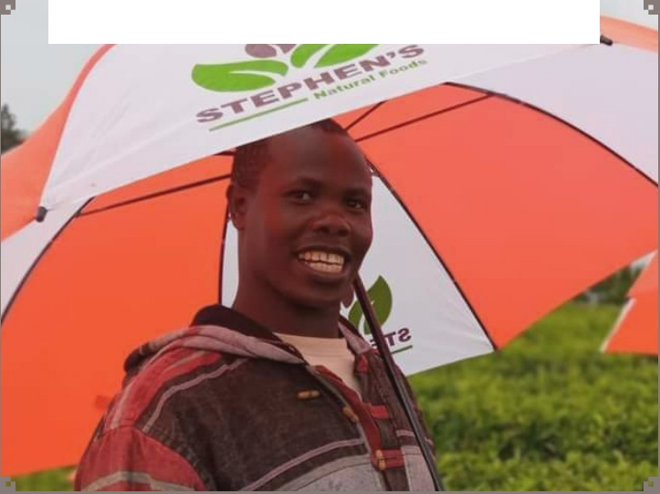

Out-growers Information Book

Since its establishment STEPHEN’S NATURAL FOODS (SNFs) has championed underutilized fruits and vegetables farming in Kenya working closely with KENYA AGRICULTURE AND LIVESTOCK RESEARCH ORGANIZATION (KALRO).

The company is a place for equal opportunities to any willing out grower.SNFs has access to both local and export market, UAE being the largest expo market.SNFs however cannot meet the

market demand with its supply potential.SNFs is willing to partner with ambitious farmers as out growers for us to meet the market supply demand as a team.

STEPHENSNATURALFOODS.COM

P.O Box 3031-00621 ,Village Market

stephensnaturalfoods @gmail.com

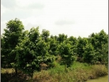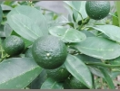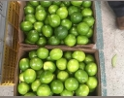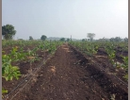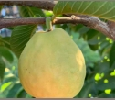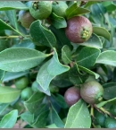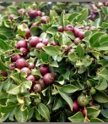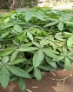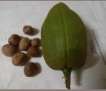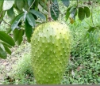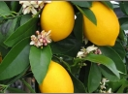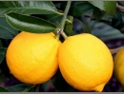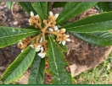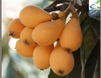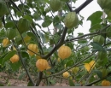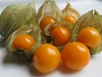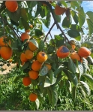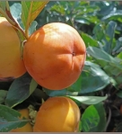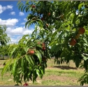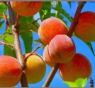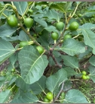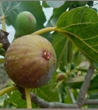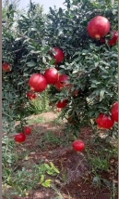

Loquat lemons

Malabar-

Strawberry

quava

Quava

Lime Soursop

Fig Fruit

Peaches

Golden

berry

Here is a list of fruit & vegetable plants we are specializing on;

|  |  |  |  |  |  |
| --- | --- | --- | --- | --- | --- |
| Plant | | Fruit | Plant | | Fruit |
|  |  |  |  |  |
|  |  |  | Persimmon |  |  |
|  |  |  |  |
|  |  |  |
|  |  |  |  |
| Pomegranate |  |  |
| chestnut |  |  |  |
|  |  |
|  |  |  |  |
|  |  |  |  |
|  | | |

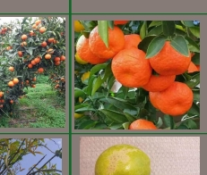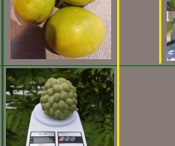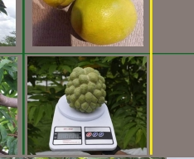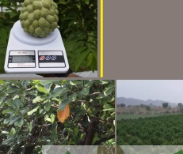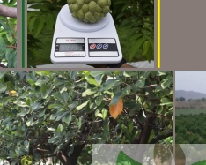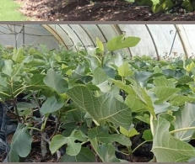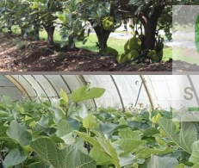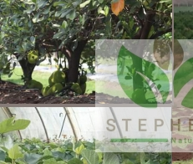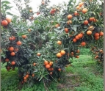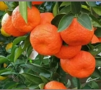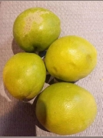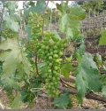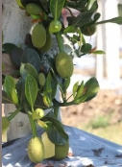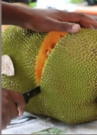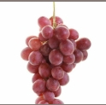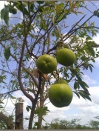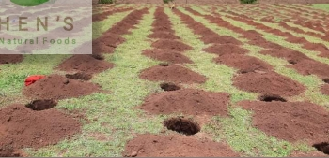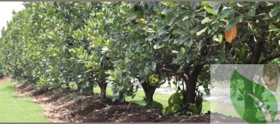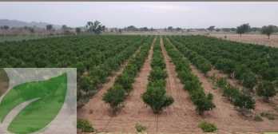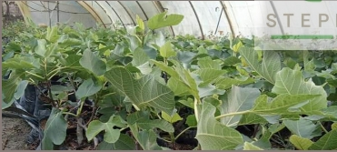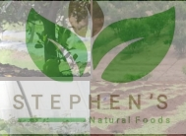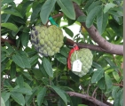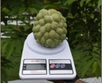

Jackfruit

Plant

Fruit

Plant

Fruit

Custard

Apple

White Supote Pixels

Jack fruit

Grapes

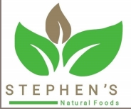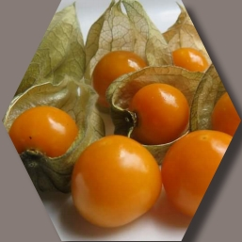

An out grower will opt to purchase either seeds or seedlings as of the table be- low.

An out grower may opt to have SNFs germinate the

golden berry seedlings at our nursery @3 ksh per seedling af-

ter purchasing

the seeds from

SNFs.

Purchasing

seeds and there-

after germinat-

ing is the cheaper way since the seeds are 1st generation compared to an already ger- minated seedling.

However ,this comes with

obstacles like time factor because it takes up to 3 months to have a ready for transplant seedling from the

nursery.

Another aspect

an out grower

might consid-

er is the risk of germinating the seeds and

ending up with non-ger- minating or dried up seed- lings at the nursery, SNFs

germinating for you

minimizes the risk

and the loss.

For the seedlings

an out grower will

also purchase as per

the tables’price. An out grower may get

into an agreement with SNFs and pay 70% of the total amount when pur-

chasing the seedlings, the

remaining 30% will be

deducted in installments from the payments the out grower will be receiving

after making sales.

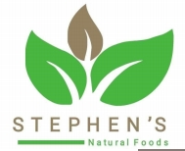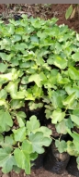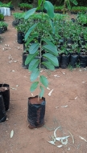

SEEDS&SEEDLINGSPRICESTABLE(ksh)

PRODUCT

Cost Of A Seedling N.O of Seedlings Medium Large Per Acre

Total Cost

Medium Large

Soursop

Quava

Strawberry quava

Lime

Malabar Chestnut

Persimmon

Jackfruit

Loquat

Lemons

Pixels

Grapes

Peaches

Pomegranate

Fig fruit

White Supote

Custard Apple

300

150

300

200

350

*

350

200

200

350

300

*

250

400

400

300

450

300

450

300

500

500

400

350

350

500

450

450

450

550

550

450

500

500

500

500

500

500

500

500

500

500

500

500

500

500

500

500

150,000

75,000

150,000

100,000

175,000

*

175,000

100,000

100,000

175,000

150,000

*

125,000

200,000

200,000

150,000

225,000

150,000

225,000

150,000

250,000

250,000

200,000

175,000

175,000

250,000

225,000

225,000

225,000

275,000

275,000

225,000

For the Giant Golden Berry we will sell seeds @11,500 ksh that will cover 1 acre of land. The out grower will germinate the golden berry seeds that will take 4 months in the nursery for the warm areas and 6 months for the cold areas.

Medium Sized Seedling Large Sized Seedling



All the underutilized fruits & vegetables SNFs is dealing with are 1st generation and rare varieties. SNFs expects the out grower once we have a working relation to keep off media interviews or sharing

information to individuals or

specialists visiting the farm to collect data. The informa- tion and varieties should be discreet as this would bring about commotion in the mar- ket. Failure to observe this guidelines may be subjected to contract termination. SNFs will buy products from the farmer at the time of har- vest and sell to the local mar- kets or export to our newly found market UAE.The out grower shall not sell products to another entity apart from SNFs.

In case of a disease or an in- fection on the plants, the out grower will contact SNFs and

follow the direc-

tives given .SNFs

advocates and is

recognized for

championing organic farm-

ing therefore using non-pre- scribed products on the farm alters the product’s quality and also is against our guide- lines.

The prices of the products upon harvesting will vary by the quality of harvest since we do grading. SNFs will have an open platform which will inform farmers the most current prices in the local and export market which

will thereafter communicate the price which a farmer will sell their products to SNFs. The prices will be influenced by factors like value addition processes and export fees. Farmers will have their pay- ments processed 2 weeks (14 days) after sales day.

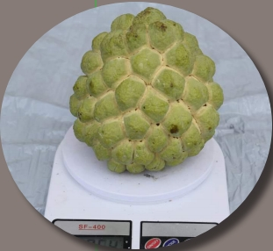

Before an out grower makes a purchase of either the seeds or seedlings, SNFs will first inspect the farm and collect data which will be worked on at the lab- oratory to know the most suitable variety for the out grower’s farm or

supply supplements

for the farm. The

minimum amount

of land or farm re-

quired is 1 acres.

Once SNFs iden-

tifies a variety that

is suitable for each

specific out grower and

payments have been made,

seedlings will be delivered prior or on the day of trans- planting.

SNFs will be on site to in- spect the whole process and offer guidelines for profes-

sionalism.

Depending

on the growth

period that

is between the planting

and the harvesting period which varies in every va- riety, SNFs will send or be

sending a

specialist

to the out

growers

farm for

inspection

purposes.

The out

grower is

to cater for transport and wellbeing of the inspecting team at the farm. If a plant gets damaged or does not grow due to any natural reason, a new plant will be brought to replace the damaged one.